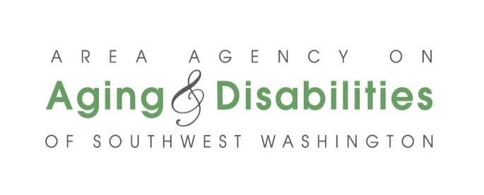
Request for Price and/or Rate Quotes Form

General Information

Information provided by responding entities will be used to identify potential contractors considered eligible to contract with AAADSW to provide client services. This is not a contract or a commitment to enter into a contract. You will be notified in writing if your entity is selected to contract with specific instructions regarding additional information that will be required prior to establishing a contract for services.

Eligibility requirements

All potential contractors responding to this announcement must meet all of the following conditions in order to be considered eligible for this procurement:
- The entity has never been debarred from doing business with a government agency.
- The entity’s staff is able to pass a Washington State Patrol Background Check.
- The entity possesses all necessary licenses, insurances, certifications or other requirements deemed necessary to the delivery of services relative to this announcement.
- There are no pending lawsuits or judgements against the entity and/or its principal owners or representatives.

The entity has complied with all provisions or conditions of an existing or former AAADSW contract.
Note: As applicable, the responding entity’s National Provider ID Number, professional licenses and/or certification numbers, proof of insurance and business licenses, and other documents will be required at the time of contract (if awarded).
Should a bid and/or rate quote result in a contract, and the responding entity does not meet the eligibility requirements, the contract would be terminated immediately.

FAMILY CAREGIVER SUPPORT PROGRAM:
COUNSELING SERVICES RATE REQUEST FORM
- Contact Information:
Name and Title:
Email Address:
Phone number (including area code):

- AAADSW Counties in which services will be delivered:
Clark Cowlitz Wahkiakum Klickitat Skamania

- Mailing address:

- Office location from which services will be provided, if different than the above mailing address. If you plan to operate from multiple addresses and/or under multiple DBAs, please provide that information on a separate page.

- Number of years in business in Washington State:
- Qualifications of the responding entity’s experience working with senior and disabled adults and/or providing this service. Please address the number of clients served annually; the total number of years in business; and the range of services provided.

- WA AAA Contract(s):
If the responding entity has a previous or existing contract with a Washington State Area Agency on Aging, please complete below:

Title of contract or service:
Name of AAA(s):
Year in which the most recent contract was signed:

- Price and/or Rate Quote
Quotes with service descriptions can also be attached to this form in lieu of completing this table below.

Title or Description of Service(s) | Price and/or Rate Quote  In US Dollars

- Length of time that the price and/or rate quote will remain valid (if applicable):

If additional space is needed for any item included, you may attach additional pages. Please put the name of the responding entity at the top of each additional page followed by the announcement title and the question(s) being responded to.

Submit this completed form along with any attachments, to:

AAADSWContracts@dshs.wa.gov

OR

Area Agency on Aging & Disabilities of Southwest Washington
Attn: Contracts Manager
201 NE 73rd Street
Vancouver, WA 98665

